STUDENTS PROJECT SCHEME

2023-2024

**SIGN LANGUAGE RECOGNITION**

Submitted by

MITHUN S

PRATHIKSHA S

SUDHAKARAN M

VENKATESH PRABHU S



**SNS College of Technology**

Coimbatore

**September 2023**

**Annexure-I**

# INTRODUCTION:

# A sign language is a language which mainly uses actions or gestures to convey meaning, as opposed to acoustically conveyed sound patterns. There are significant differences between signed and spoken languages, because of the constraints offered by visual gestures. Yet the two are fundamentally similar as both have their own syntax and semantics. Groups of hearing and speech impaired people have used signs to communicate since many years and so sign language is developed among them

# OBJECTIVES:

# ASL recognition is not a new computer vision problem Over the past 20 years,

# researchers have used classifiers from a variety of categories that we can classify

# roughly into linear classifiers, neural networks and Bayesian networks. A real-time sign language translator is an important milestone in facilitating

# communication between the deaf community

**IMPLEMENTATION**

These algorithms use labeled data for training the model. In other words, we can say that for a given set of features, the model learns to predict a target value. The term “supervised” is derived from the idea that the model is learning from the training dataset under the supervision of a teacher. The model learns while optimizing for the maximum possible correct predictions for the validation data.

The model used must be simple and fast enough to detect the anomaly and classify it as a fraudulent transaction as quickly as possible.

Imbalance can be dealt with by properly using some methods which we will talk about in the next paragraph

For protecting the privacy of the user the dimensionality of the data can be reduced.

A more trustworthy source must be taken which double-check the data, at least for training the model.

We can make the model simple and interpretable so that when the scammer adapts to it with just some tweaks we can have a new model up and running to deploy.

**Hardware Specifications**:

* Windows 10, Mac OS, Ubuntu
* Ram - 4GB (minimum)
* Hard disk - 256GB (minimum)
* Processor - Intel i3 (minimum)

**Software Specifications:**

* Anaconda Navigator.
* Spyder / VS Code / Pycharm.
* Machine learning libraries.

# WORK PLAN

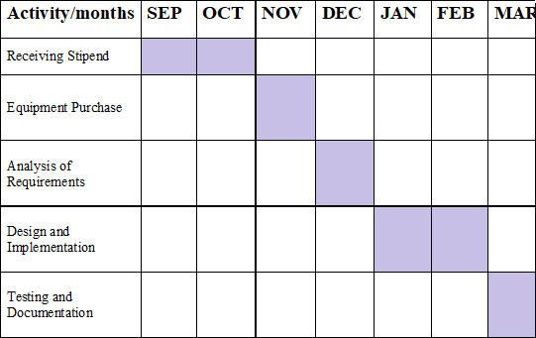

**BUDGET**

|  |  |  |
| --- | --- | --- |
| **S. No** | **Components and Expenditure** | **Cost**  (Rs.) |
| i | Database, Cloud, AWS connection | 5000 |
|  | **TOTAL** | 5000 |